**Pom.xml**

<project xmlns="http://maven.apache.org/POM/4.0.0" xmlns:xsi="http://www.w3.org/2001/XMLSchema-instance" xsi:schemaLocation="http://maven.apache.org/POM/4.0.0 https://maven.apache.org/xsd/maven-4.0.0.xsd">

<modelVersion>4.0.0</modelVersion>

<groupId>com.cdac</groupId>

<artifactId>Spring-Hibernate-App</artifactId>

<version>0.0.1-SNAPSHOT</version>

<name>Spring-Hibernate-App</name>

<description>Spring Hibernate App</description>

<properties>

<spring.version>4.3.20.RELEASE</spring.version>

<aspectj.version>1.8.13</aspectj.version>

<mysql.connector.version>8.0.13</mysql.connector.version>

<hibernate.version>4.3.0.Final</hibernate.version>

</properties>

<dependencies>

<!-- Spring dependencies -->

<dependency>

<groupId>org.springframework</groupId>

<artifactId>spring-core</artifactId>

<version>${spring.version}</version>

</dependency>

<dependency>

<groupId>org.springframework</groupId>

<artifactId>spring-beans</artifactId>

<version>${spring.version}</version>

</dependency>

<dependency>

<groupId>org.springframework</groupId>

<artifactId>spring-context</artifactId>

<version>${spring.version}</version>

</dependency>

<dependency>

<groupId>org.springframework</groupId>

<artifactId>spring-context-support</artifactId>

<version>${spring.version}</version>

</dependency>

<dependency>

<groupId>org.springframework</groupId>

<artifactId>spring-jdbc</artifactId>

<version>${spring.version}</version>

</dependency>

<dependency>

<groupId>org.springframework</groupId>

<artifactId>spring-orm</artifactId>

<version>${spring.version}</version>

</dependency>

<dependency>

<groupId>org.springframework</groupId>

<artifactId>spring-web</artifactId>

<version>${spring.version}</version>

</dependency>

<dependency>

<groupId>org.springframework</groupId>

<artifactId>spring-webmvc</artifactId>

<version>${spring.version}</version>

</dependency>

<dependency>

<groupId>org.springframework</groupId>

<artifactId>spring-aop</artifactId>

<version>${spring.version}</version>

</dependency>

<dependency>

<groupId>org.aspectj</groupId>

<artifactId>aspectjrt</artifactId>

<version>${aspectj.version}</version>

</dependency>

<dependency>

<groupId>org.aspectj</groupId>

<artifactId>aspectjweaver</artifactId>

<version>${aspectj.version}</version>

</dependency>

<!-- https://mvnrepository.com/artifact/mysql/mysql-connector-java -->

<dependency>

<groupId>mysql</groupId>

<artifactId>mysql-connector-java</artifactId>

<version>${mysql.connector.version}</version>

</dependency>

<!-- hibernate dependencies -->

<dependency>

<groupId>org.hibernate</groupId>

<artifactId>hibernate-core</artifactId>

<version>5.6.9.Final</version>

</dependency>

<dependency>

<groupId>org.hibernate</groupId>

<artifactId>hibernate-entitymanager</artifactId>

<version>${hibernate.version}</version>

</dependency>

<dependency>

<groupId>org.hibernate</groupId>

<artifactId>hibernate-ehcache</artifactId>

<version>${hibernate.version}</version>

</dependency>

</dependencies>

</project>

**cfg.xml**

<?xml version="1.0" encoding="UTF-8"?>

<beans xmlns="http://www.springframework.org/schema/beans"

xmlns:xsi="http://www.w3.org/2001/XMLSchema-instance"

xmlns:aop="http://www.springframework.org/schema/aop"

xmlns:context="http://www.springframework.org/schema/context"

xmlns:jdbc="http://www.springframework.org/schema/jdbc"

xmlns:mvc="http://www.springframework.org/schema/mvc"

xmlns:p="http://www.springframework.org/schema/p"

xsi:schemaLocation="http://www.springframework.org/schema/beans http://www.springframework.org/schema/beans/spring-beans-4.3.xsd http://www.springframework.org/schema/aop http://www.springframework.org/schema/aop/spring-aop-4.3.xsd http://www.springframework.org/schema/context http://www.springframework.org/schema/context/spring-context-4.3.xsd http://www.springframework.org/schema/jdbc http://www.springframework.org/schema/jdbc/spring-jdbc-4.3.xsd http://www.springframework.org/schema/mvc http://www.springframework.org/schema/mvc/spring-mvc-4.3.xsd">

<context:component-scan base-package="com.cdac"></context:component-scan>

<bean id="dataSource"

class="org.springframework.jdbc.datasource.DriverManagerDataSource" autowire="byType">

<property name="driverClassName"

value="com.mysql.cj.jdbc.Driver" />

<property name="url"

value="jdbc:mysql://localhost:3306/pune?userSSL=false" />

<property name="username" value="root" />

<property name="password" value="cdac" />

</bean>

<bean id="sessionFactory"

class="org.springframework.orm.hibernate4.LocalSessionFactoryBean"

autowire="byType">

<property name="hibernateProperties">

<props>

<prop key="hibernate.dialect">org.hibernate.dialect.MySQLDialect</prop>

<prop key="hibernate.show.sql">true</prop>

<prop key="hibernate.hbm2ddl.auto">update</prop>

</props>

</property>

<property name="annotatedClasses">

<list>

<value>com.cdac.model.Car</value>

</list>

</property>

</bean>

<bean id="hibernateTemplate"

class="org.springframework.orm.hibernate4.HibernateTemplate" autowire="byType">

</bean>

</beans>

**Car.java**

package com.cdac.model;

import javax.persistence.Entity;

import javax.persistence.GeneratedValue;

import javax.persistence.GenerationType;

import javax.persistence.Id;

@Entity

public class Car {

@Id

@GeneratedValue(strategy = GenerationType.IDENTITY)

private int id;

private String make;

private String model;

private float price;

public Car() {

}

public Car(int id) {

super();

this.id = id;

}

public Car(String make, String model, float price) {

super();

this.make = make;

this.model = model;

this.price = price;

}

public Car(int id, String make, String model, float price) {

super();

this.id = id;

this.make = make;

this.model = model;

this.price = price;

}

public int getId() {

return id;

}

public void setId(int id) {

this.id = id;

}

public String getMake() {

return make;

}

public void setMake(String make) {

this.make = make;

}

public String getModel() {

return model;

}

public void setModel(String model) {

this.model = model;

}

public float getPrice() {

return price;

}

public void setPrice(float price) {

this.price = price;

}

@Override

public String toString() {

return id + " " + make + " " + model + " " + price;

}

}

**CarDao.java**

package com.cdac.dao;

import java.util.List;

import com.cdac.model.Car;

public interface CarDao {

public void save(Car car);

public void update(Car car);

public void deleteById(int id);

Car selectById(int id);

List<Car> selectAll();

}

**CarDaoImpl.java**

package com.cdac.dao;

import java.util.List;

import org.hibernate.Transaction;

import org.springframework.beans.factory.annotation.Autowired;

import org.springframework.orm.hibernate4.HibernateTemplate;

import org.springframework.stereotype.Repository;

import com.cdac.model.Car;

@Repository

public class CarDaoImplementation implements CarDao {

@Autowired

private HibernateTemplate hibernateTemplate;

@Override

public void save(Car car) {

hibernateTemplate.execute(session -> {

Transaction t = session.beginTransaction();

t.commit();

session.save(car);

session.flush();

session.close();

return null;

});

}

@Override

public void update(Car car) {

hibernateTemplate.execute(session -> {

Transaction t = session.beginTransaction();

t.commit();

session.update(car);

session.flush();

session.close();

return null;

});

}

@Override

public void deleteById(int id) {

hibernateTemplate.execute(session -> {

Transaction t = session.beginTransaction();

session.delete(new Car(id));

t.commit();

session.flush();

session.close();

return null;

});

}

@Override

public Car selectById(int id) {

return hibernateTemplate.execute(session -> {

Transaction t = session.beginTransaction();

Car car = (Car) session.get(Car.class, id);

t.commit();

session.flush();

session.close();

return car;

});

}

@Override

public List<Car> selectAll() {

// **TODO** Auto-generated method stub

return null;

}

}

**CarService.java**

package com.cdac.service;

import java.util.List;

import com.cdac.model.Car;

public interface CarService {

public void add(Car car);

public void modify(Car car);

public void removeById(int id);

public Car getById(int id);

List<Car> getAll();

}

**CarServiceImpl.java**

package com.cdac.service;

import java.util.List;

import org.springframework.beans.factory.annotation.Autowired;

import org.springframework.stereotype.Service;

import com.cdac.dao.CarDao;

import com.cdac.model.Car;

@Service

public class CarServiceImplements implements CarService {

@Autowired

private CarDao carDao;

@Override

public void add(Car car) {

carDao.save(car);

}

@Override

public void modify(Car car) {

carDao.update(car);

}

@Override

public void removeById(int id) {

carDao.deleteById(id);

}

@Override

public Car getById(int id) {

return carDao.selectById(id);

}

@Override

public List<Car> getAll() {

return carDao.selectAll();

}

}

**Main.java**

package com.cdac;

import org.springframework.context.ApplicationContext;

import org.springframework.context.support.ClassPathXmlApplicationContext;

import com.cdac.model.Car;

import com.cdac.service.CarService;

public class CarMain {

public static void main(String[] args) {

ApplicationContext appCntx = new ClassPathXmlApplicationContext("cfg.xml");

CarService carService = (CarService) appCntx.getBean(CarService.class);

Car car = new Car("Tata Safari", "Q2", 2567.25f);

carService.add(car);

}

}

**Project Structure**

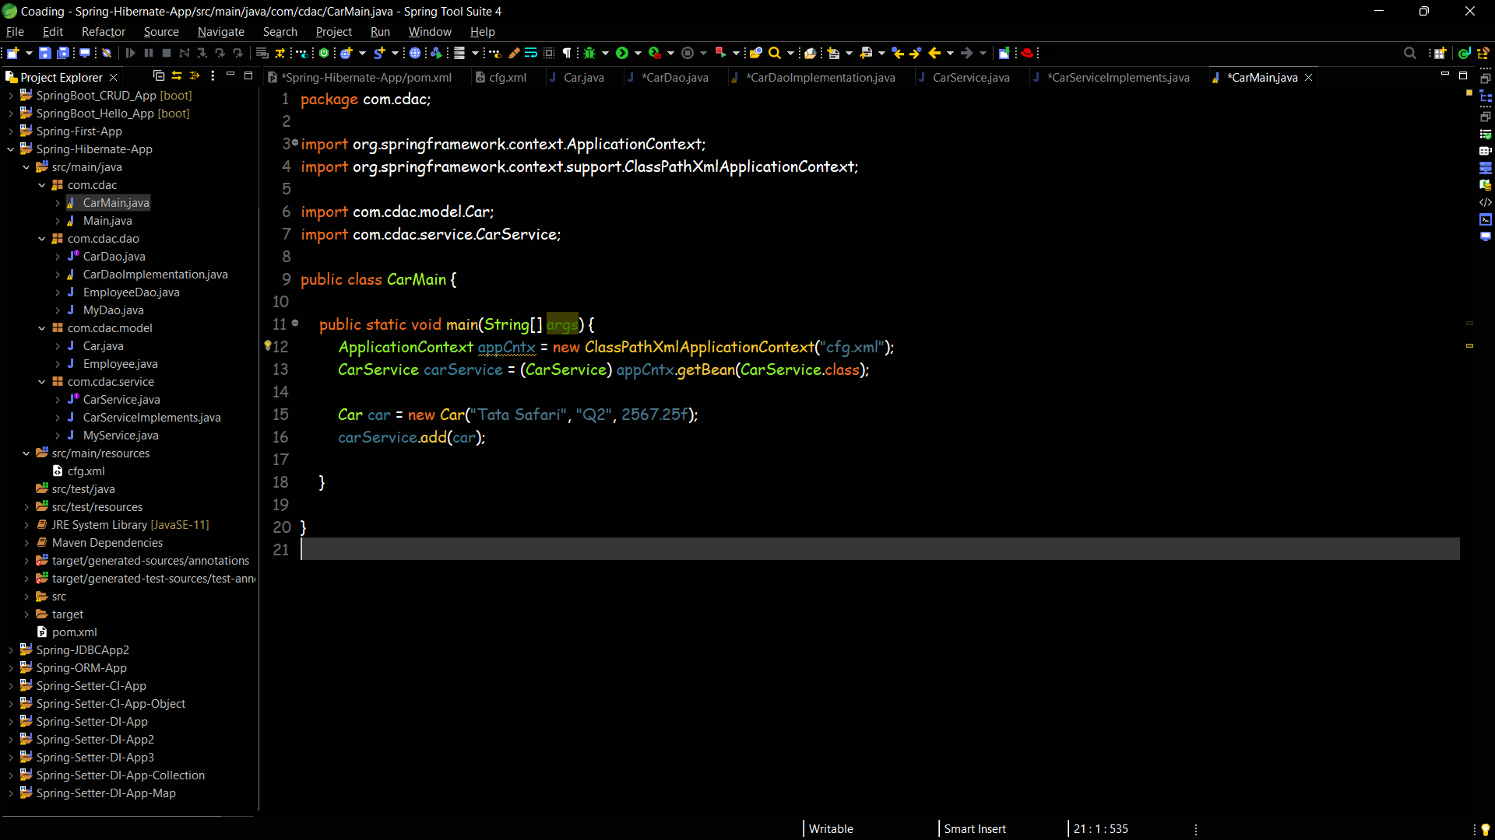

**Database Data**

